**PROBABILITY GREATER OR LOWER THAN**

The burst strength of 15 randomly selected seals are 480, 489, 491, 508, 501, 500, 486, 499, 479, 496, 499, 504, 501, 496, 498

What is the probability that the burst strength of the population is greater than 500?

The mean is 495.13 and the sample standard deviation is 8.467.

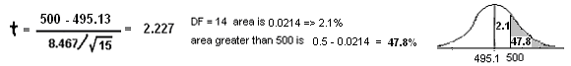

The diameter of a population is **normally distributed** with a mean of 75 and a standard deviation is 8.

What probability the average of 10 randomly being LOWER than 77? 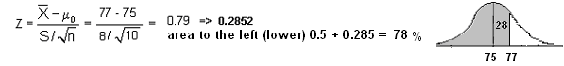

No aplica t porque es normally distributed, and not a simple information